MLA Format: The Basics
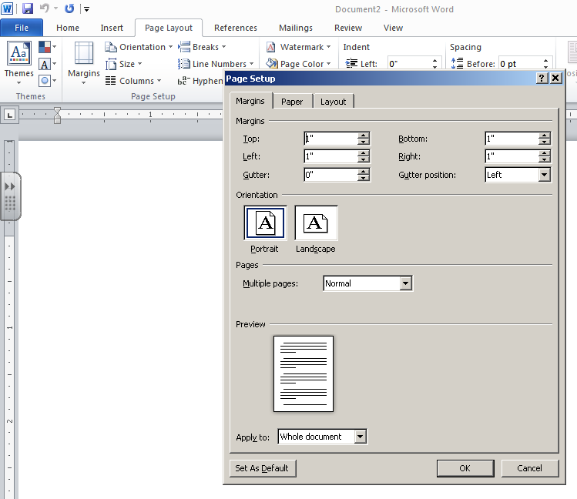
- Open Microsoft Word: Click on Start Menu > All Programs > Microsoft Office Word

- Change Margins: Page Layout > Margins > Set Top, Left, Bottom and Right Margins to 1” > Click OK.

- Insert Header: Double click in Header area> Click Page Number Drop Down Menu, Choose Top of Page > Plain Number 3 > Type Last name before number > Double click outside of Header to go back to typing.
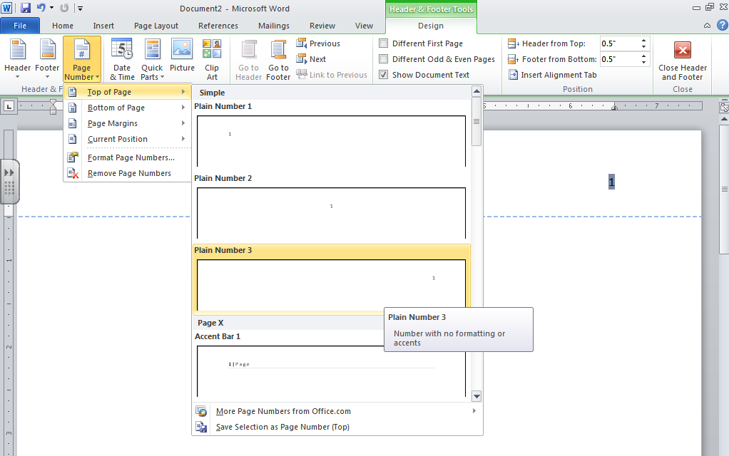

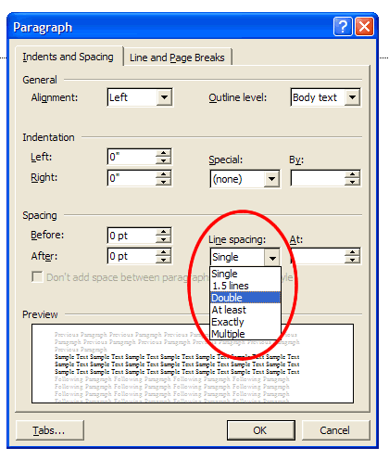

Double Space: Page Layout > Paragraph > Change Line Spacing from Single to Double > Make sure Spacing Before and After are at 0 pt. > Click OK

- Type Heading: List your name, your instructor's name, the course, and the date.

Example:

Joe Smith
Ms. Seiberling
Language Arts
4 November 2015
- Title: Type title. Capitalize first word, last word, and all important words in between. Do not underline, italicize, or place your title in quotation marks. Center Title by highlighting > Click
Center Icon on tool bar.

- Double space between the title and the first line of the text.
- Indent Paragraphs: Use Tab Key to indent.

